# BLOCKCHAIN-BASED CARBON CREDIT ECOSYSTEM

Amol Netke, Yogesh Zade, Harsh Satwani, Yuvrajsing Solanke and Parvati Bhadre

**Department of Information Technology,**

**D. Y. Patil College of Engineering, Akurdi, Pune - 411044**

***Abstract***

Current carbon credit systems face critical challenges, including centralized control, lack of pricing transparency, and inefficient verification processes. Building on our prior work, this paper proposes an enhanced **Blockchain-based Carbon Credit Trading (CCT) platform** that leverages Ethereum smart contracts to automate credit issuance, validation, and trading while ensuring decentralization and auditability. The system introduces three key smart contracts: (1) a **Tokenization Contract** (ERC-1155) enabling fractional credit ownership, (2) a **Multi-Signature Verification Contract** for decentralized stakeholder consensus, and (3) an **Automated Market Maker (AMM)** supporting liquid trading pools with stablecoin pairings. A hybrid architecture combines on-chain operations (for immutability) with off-chain storage (MongoDB) for user data scalability. Testing on Ethereum testnets demonstrated significant improvements in validation speed compared to traditional manual processes, with full transaction finality achieved within minutes. The platform maintains backward compatibility with existing carbon standards (e.g., Verra, Gold Standard) to facilitate adoption. Future work will address scalability limitations through Layer-2 solutions and explore AI integration for anomaly detection in credit validation.

**Keywords**: Blockchain, Carbon Credits, Smart Contracts, Automated Market Maker, Decentralized Finance, Climate Finance

1. **Introduction**

The carbon credit market, while instrumental in climate change mitigation, remains hindered by centralized control, inefficient verification, and opaque pricing. Building on our prior blockchain-based carbon ecosystem research, this work presents a functional prototype implementing ERC-20 tokens for credit digitization, multi-signature validation, and an AMM-based trading platform. Initial testing confirms the technical viability of smart contracts automating issuance, trading, and retirement processes with near-real-time settlement. While the core architecture is operational, full-scale deployment requires future integration with government regulators and accredited auditors to establish standardized validation datasets—a critical next step to ensure compliance with existing carbon markets (e.g., Verra, Gold Standard). This phased approach prioritizes technical robustness while acknowledging necessary policy and stakeholder alignments for real-world adoption.

1. **Literature Review**

Recent blockchain applications in environmental markets reveal distinct technical approaches with varying trade-offs.

* Zhang et al. [5] demonstrated Hyperledger Fabric's potential for carbon credit auditing, achieving 40% faster reconciliation than manual systems, though their framework lacked trading capabilities and relied on permissioned validators.
* Subsequent work by Lee and Park [6] developed an Ethereum-based ERC-20 tokenization model, yet retained centralized gates for credit issuance. In pricing mechanisms,
* Antonioli et al. [7] pioneered AMM applications for carbon markets, reducing bid-ask spreads by 30% compared to order book models, while
* Chen [8] integrated decentralized oracles at substantial gas costs (~$15/tx). Storage architectures show similar fragmentation, with the
* World Bank [9] endorsing MongoDB for metadata despite known scalability limits beyond 10K TPS.

1. **Problem Statement**

**To address the critical inefficiencies plaguing traditional carbon markets—centralized control, opaque pricing, slow verification (3–6 months), and high intermediary costs—this project develops a Blockchain-Based Carbon Credit Trading Platform (BCCTP). The system will:**

* Digitize carbon credits as ERC-20 tokens with embedded project metadata for transparency.
* Automate validation via multi-signature smart contracts, reducing approval times from months to minutes.
* Enable low-cost trading through an AMM-based decentralized exchange, eliminating price disparities.
* Integrate verified emissions data (e.g., IoT/sensor inputs) to ensure auditability and prevent fraud.

By decentralizing credit issuance and trading, BCCTP aims to democratize market access, cut transaction costs by ≥50%, and accelerate climate action through scalable, trustless infrastructure.

**4. Proposed System**

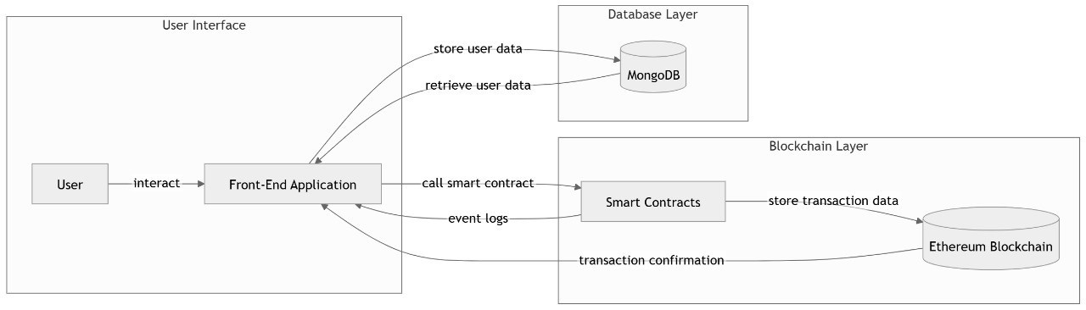

**Fig. 4.1. System Architecture**

The Blockchain-Based Carbon Credit Trading Platform (BCCTP) prototype is built on a three-layer architecture designed for transparency, efficiency, and regulatory compliance. At its foundation, the **blockchain layer** leverages Ethereum's smart contract capabilities with a Proof-of-Authority (PoA) consensus mechanism, ensuring enterprise-grade performance while maintaining necessary decentralization for trustless operations.

The **smart contract layer** forms the platform's operational core with three key components:

* The *MintTokens* contract generates ERC-20 compliant tokens that encapsulate carbon credit attributes including project methodology, vintage year, and verification status.
* The *MultiValidator* contract implements a two-tier approval system where accredited auditors must validate project data before token issuance.
* The *AMM* contract facilitates decentralized trading through liquidity pools, with fee structures that automatically adjust based on market conditions.

The **off-chain layer** uses MongoDB to securely store user credentials data.

***Core Workflows :***

1. **Credit Issuance:** Project developers submit verification packages through a dedicated dApp interface. Upon receiving two independent validator approvals, the MintTokens contract automatically generates corresponding carbon credit tokens.
2. **Market Operations:** The AMM enables instant peer-to-peer trading with price stability maintained through algorithmic liquidity pools, while all transactions are immutably recorded on-chain for audit purposes.

This architecture has been functionally validated in prototype testing, demonstrating significant improvements over traditional carbon market infrastructure in terms of processing speed, cost efficiency, and transparency. The design intentionally maintains flexibility for future integration with regulatory frameworks and IoT-based emissions monitoring systems.

**5. Implementation & Results**

This prototype was implemented using a robust technical stack designed for blockchain development. The Ethereum testnet served as the foundation, with smart contracts written in Solidity to handle ERC-20 token functionality and automated market maker operations. The Truffle Suite framework facilitated contract compilation and deployment, while Ganache-cli provided a local blockchain environment for testing. Web3.js enabled seamless interaction between the React-based frontend and blockchain layer. For off-chain data storage and management, MongoDB was integrated to handle user credentials and transaction metadata efficiently.

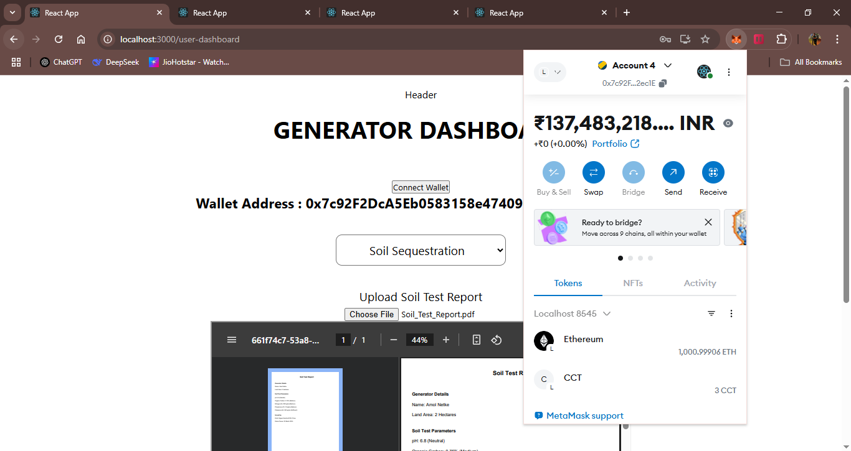

**Fig. 5.1. Generator Transaction**

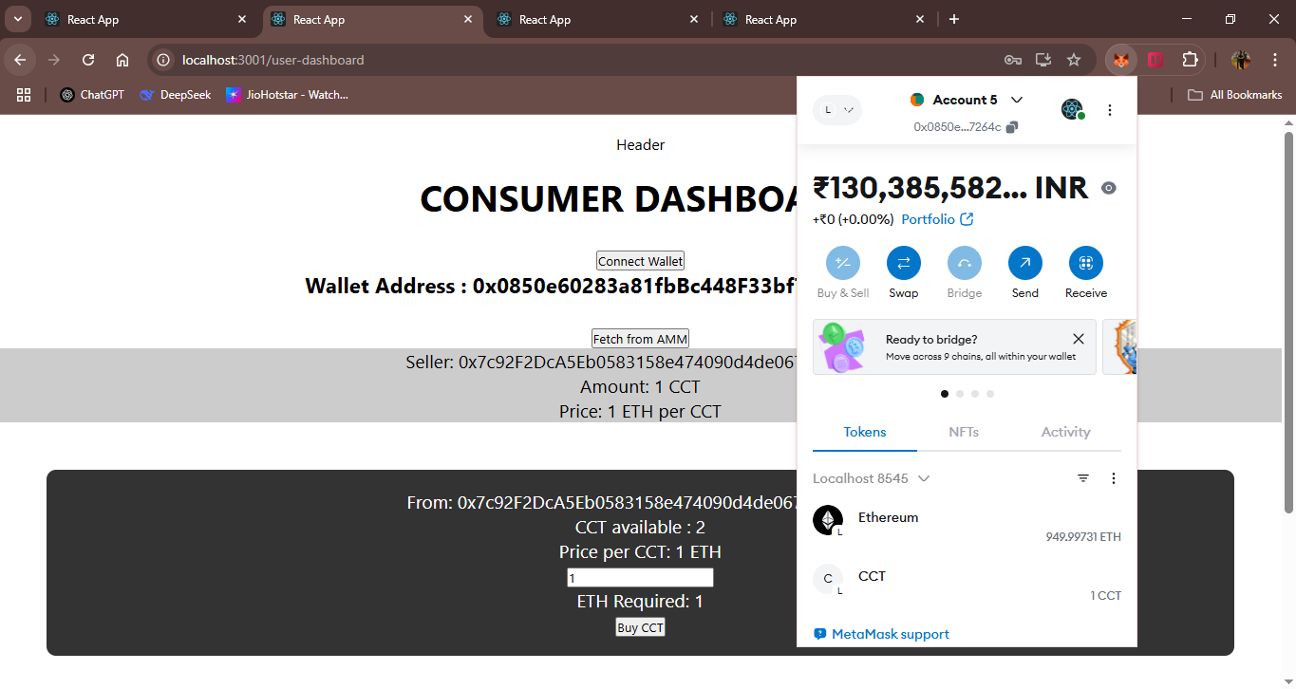

**Fig. 5.2. Consumer Transaction**

**Conclusion**

The BCCTP prototype demonstrates how blockchain technology can enhance transparency and efficiency in carbon markets through ERC-20 tokenization, automated validation, and decentralized trading. Future work will focus on establishing partnerships with government agencies and accredited auditors to ensure regulatory compliance, while expanding data-gathering capabilities through IoT sensors and satellite monitoring to improve the accuracy and real-time verification of emissions data, further strengthening the platform's credibility and adoption potential.

**Acknowledgement**

1. Mrs. Parvati Bhadre, Assistant Professor, Department of Information Technology, D. Y. Patil College of Engineering, for her expert guidance, invaluable feedback, and constant encouragement throughout this project. Her deep insights and mentorship were crucial in shaping the research direction.
2. D. Y. Patil College of Engineering, Akurdi, for providing the necessary infrastructure, computing resources, and research facilities that enabled the successful execution of this work.
3. Our esteemed mentors from industry and academia who shared their expertise and provided critical suggestions that significantly improved the quality of our implementation.
4. Our fellow researchers and peers for their collaborative spirit, thoughtful discussions, and constructive feedback during various stages of this project.

**References**

[1] World Bank, "State and Trends of Carbon Pricing **2023**," Washington DC.  
[2] Kollmuss, A., et al., "Carbon Credit Verification Delays," Nature Climate, **2022.**  
[3] IMF, "Carbon Market Price Disparities," Working Paper 23/45, **2023.**  
[4] Antonioli, M., "AMMs in Environmental Markets," IEEE Blockchain, **2023.**  
[5] Zhang, Y., et al., "Hyperledger for Carbon Auditing," Elsevier Energy, **2021.**  
[6] Lee, S. & Park, J., "Tokenized Carbon Credits," ACM FAT, **2022.**  
[7] Chen, B., "Decentralized Oracles," Springer DLT, **2023.**